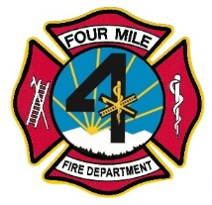 Four Mile Fire Protection District

**Regular Meeting of the Board of Directors**

**July 19, 2023**

Notice is hereby given that a regular meeting of the Board of Directors of the Four Mile Fire Protection District will be held at 8437 Teller County Road 11, Florissant, Colorado 80816, on Wednesday, July 19, 2023, at 7:00 p.m**.**

**Effective May 25, 2022, we will no longer entertain comments from the public during the board meetings. Public comments will be welcomed near the end of the meeting just as your agenda indicates. Everyone will be given 3 minutes to speak. If we are unable to answer your question,**

**it will be answered at the next board meeting.**

**Agenda**

1. Call to Order_________, include date.
   1. Roll call for quorum.
2. Previous Minutes – 6/21/2023
3. Treasurer’s Report
   1. Vote to approve June financials.
4. Old Business
   1. Update BBQ
   2. Update Land Purchase
5. New Business:
   1. New Board Member
   2. Update Bylaws
   3. Sponsorship Program
   4. Social Media Policy
6. Chief’s Report:
7. Donations:
8. Public Comment:
9. Adjournment at ______

**This meeting is open to the public, except for any Executive Session.**